DRAFT

Abhi is the Project Controls Manager for the WestConnex Program of Works on behalf of Sydney Motorway Corporation. He brings over 15 years of international and Australian experience in project management and controls of large capital projects and capital project management systems setup. He has established risk based contingency frameworks for major capital projects in the mining and infrastructure sector.

Leo is an Associate Director at TBH with excellent Project Controls skills; Planning and Cost with over 20 Years’ experience on projects.  
He has extensive experience with Project Management Software, both planning (in particular Primavera), and cost control packages. He is   
very proficient in contract administration; evaluating progress claims, extension of time, delay & variation claims.

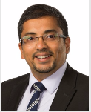 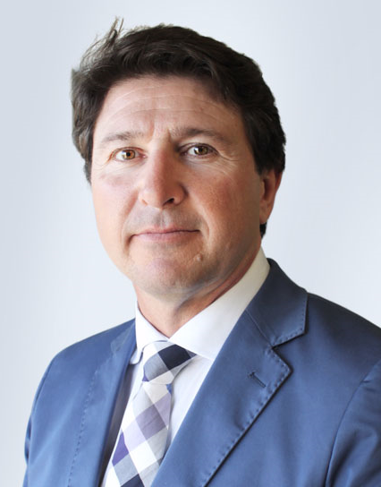

REGISTER NOW

engineersaustralia.org.au

Organisations are continuously trying to have project controls established to provide a single source of truth for large projects which have a potential to have a great impact on its balance sheets. Recently, one of the British state's biggest contractors collapsed, putting thousands of jobs at risk, after creditors and the government refused to bail out a company struggling under the weight of more than 1.5 billion pounds ($2.1 billion) of debt

We will run through a case study for performance improvement on a large EPC (Engineering, Procurement and Construction) company where you will get to know the role of project controls and its importance to large organisations.

There will be a specific session about making project controls as a career option and how this could take you places and you would never stand still. You will challenge yourself at every step and get to see the world while building a better world in stages.

**Speakers for the evening:**

**Abhi Datta – Project Controls Manager, Sydney Motorway Corporation**

**Leo Ferro – Associate Director, TBH**

**VENUE**

UTS, Dr Chau Chak Building

[Address](https://www.google.com.au/search?dcr=0&q=dr+chak+chau+address&stick=H4sIAAAAAAAAAOPgE-LVT9c3NEw2Nc7KirfI1pLNTrbSz8lPTizJzM-DM6wSU1KKUouLAbkHdAgwAAAA&sa=X&ved=0ahUKEwjzjafMn5DaAhXIsJQKHSp9CjUQ6BMIvwEwEw): Building 8, 14-28 Ultimo Rd, Ultimo NSW 2007

Room CB08.08.002

**DATE & TIME**

16th May 2018

6.00 pm for a 6.30 pm start

6.30 pm to 7.30 pm presentation

8.00 pm End.

Light refreshments will be provided prior to the presentation.

**CPD**

Eligible for 2 Continuing Professional Development (CPD) hours

**TICKETS (incl. GST)**

UTS students: Free

ACES/AACEI Members & Students: $10

Non-members: $40